# Microsoft Azure PAAS services for Tel-Aviv Panorama

Introduction

MS Azure provides a broad range of PAAS ML solutions for different tasks. Among the following services seems to be relevant to Tel-Aviv Municipality needs as stems from ***DigiTel Panorama*** project:

## [Anomaly Detector](https://docs.microsoft.com/en-us/azure/cognitive-services/anomaly-detector/) API

Monitor data over time and detect anomalies with machine learning. Get insight into your data, regardless of volume, industry, or scenario. This is only API service. See Metrics Adviser for UI-oriented service.

## [Form Recognizer](https://docs.microsoft.com/en-us/azure/cognitive-services/form-recognizer/)

Generally, this service extract various structured data from pre-build or custom-created forms and documents. You train the service to recognize the pre-defined fields (areas) in you document. Form Recognizer then, when trained, exports the structured data from there in JSON format.

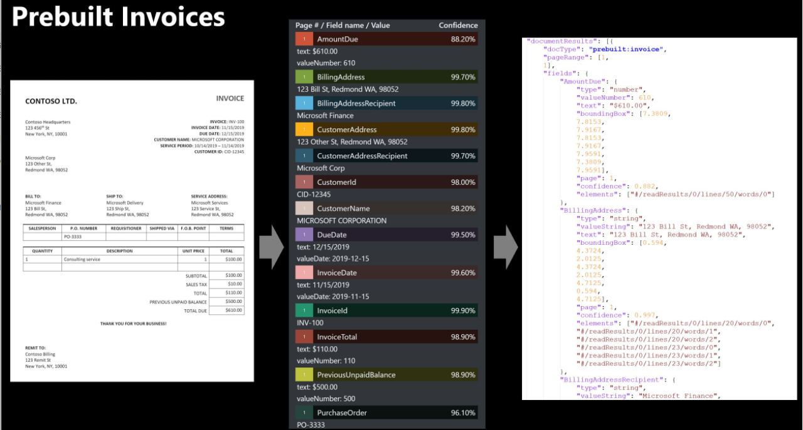

## [Metrics Adviser](https://docs.microsoft.com/en-us/azure/cognitive-services/metrics-advisor/)

Performs data monitoring and anomaly detection in time series data. he service automates the process of applying models to your data, and provides a set of APIs web-based workspace for data ingestion, anomaly detection, and diagnostics - without needing to know machine learning. Use Metrics Advisor to:

* Analyze multi-dimensional data from multiple data sources.
* Identify and correlate anomalies.
* Configure and fine-tune the anomaly detection model used on your data.
* Diagnose anomalies and help with root cause analysis.

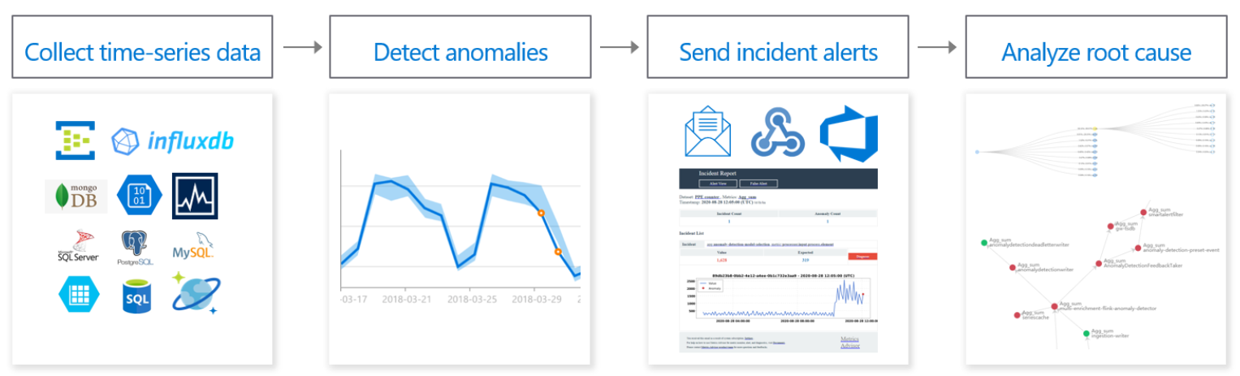

## [Azure Stream Analytics](https://docs.microsoft.com/en-us/azure/stream-analytics/)

(Not strictly ML, positioned in "Analytics" category) Fully managed, real-time analytics service designed to help you analyze and process fast moving streams of data that can be used to get insights, build reports or trigger alerts and actions

## [Personalizer](https://docs.microsoft.com/en-us/azure/cognitive-services/personalizer/)

Enables application to choose the best experience to show to your users, learning from their real-time behavior. !!!

## [Azure Machine Learning](https://docs.microsoft.com/en-us/azure/machine-learning/).

This is Microsoft's PAAS solution for various ML analytics scenarios. Based on CNTK, the Microsoft Engine for different ML tasks (the competitor of TensorFlow and PyTorch), it enables to create models based on deployed patterns or custom model build from pre-created blocks. Generally, it greatly simplifies the process of developing, training and evaluation of the ML.

This PAAS service is comprise of three components

1. Jupyter Notebooks - **retried**
2. Automated ML
3. Designer that is explained as "drag-and-drop interface from preparing data to deploying models"

**How to feed the model with external events (analog of TensorFlow IO)**

## Pricing

|  |  |  |  |
| --- | --- | --- | --- |
| Service |  | Depends on |  |
| Anomaly Detector | [Pricing](https://azure.microsoft.com/en-us/pricing/details/cognitive-services/anomaly-detector/) |  |  |
| Metrics Adviser | [Pricing](https://azure.microsoft.com/en-us/pricing/details/cognitive-services/metrics-advisor/) |  |  |
| [Azure Stream Analytics](https://docs.microsoft.com/en-us/azure/stream-analytics/) | [Pricing](https://azure.microsoft.com/en-us/pricing/details/stream-analytics/) | Event Hubs  (Opt.) Azure IoT Hubs | [Pricing](https://azure.microsoft.com/en-us/pricing/details/event-hubs/)  [Pricing](https://azure.microsoft.com/en-us/pricing/details/iot-hub/) |
| Azure Machine Learning | [Pricing](https://azure.microsoft.com/en-us/pricing/details/machine-learning/) |  |  |
| Form Recognizer | [Pricing](https://azure.microsoft.com/en-us/pricing/details/cognitive-services/form-recognizer/) |  |  |
|  |  |  |  |
|  |  |  |  |

# Microsoft Power Automate with Office 365 tools

* *Note: this site built with React*

Power Automate demonstated here with Forms Designer, Planner, Flow SQL Server Connector (for on-premise SQL Server instance) and [Azure Automation](https://azure.microsoft.com/en-us/services/automation/).

The Flow SQL Server connector is used with [On-Premise Data Gateway](https://powerapps.microsoft.com/en-us/downloads/) (part of Power Apps). This connector requires MS Corporate Account.

The following picture demonstrates the configured On-Premise Data Gateway up and running: 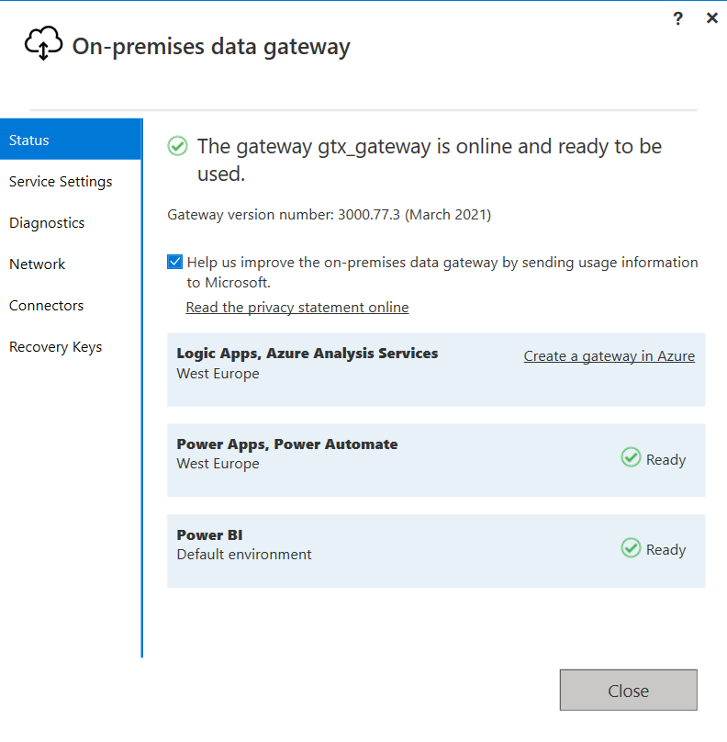

And now SQL Connector may be configured to use On-Premise Data Gateway:

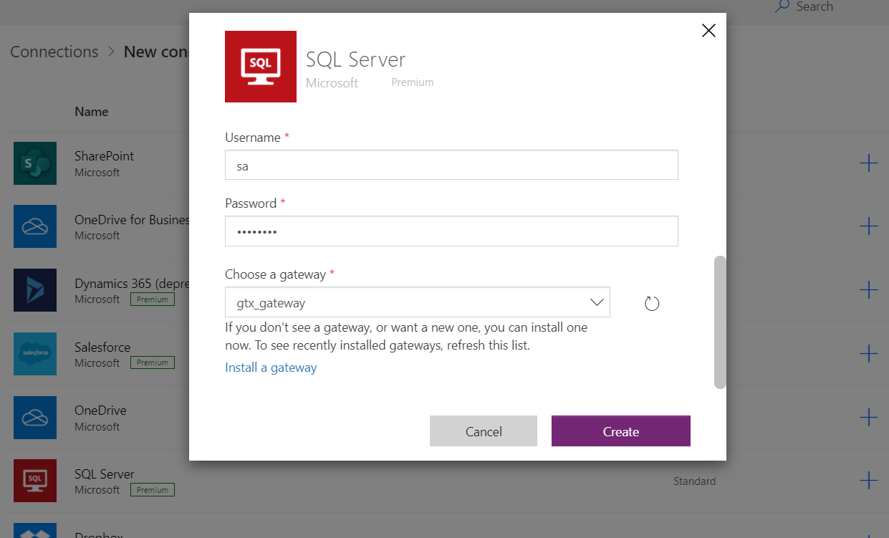

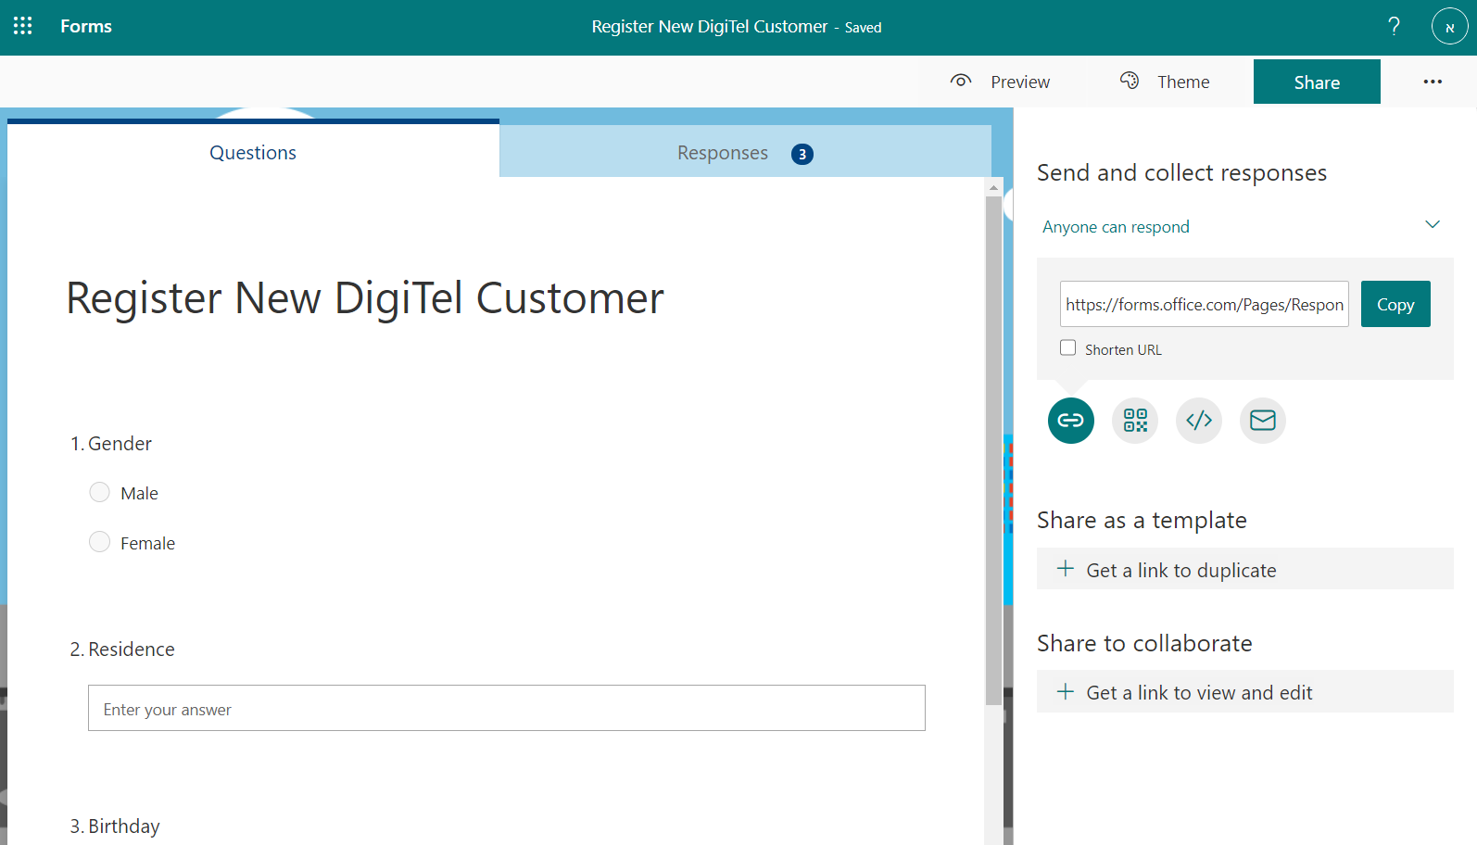

## Pricing

|  |  |  |
| --- | --- | --- |
| **Product** | **Pricing** | **Notes** |
| [Power Automate](https://flow.microsoft.com/en-us/) | [pricing](https://flow.microsoft.com/en-us/pricing/) | Additionally, may be priced as part of Office 365 |
| Desktop Flows |  |  |
|  |  |  |
| Azure Automation | Part of Azure subscription |  |